Lesson 04 Demo 01

Moving a Resource to Another Resource Group

Objective: To move a resource to another resource group
Tools Required: Resource group

Prerequisites: Two resource groups and one storage account

Steps to be followed:
- Move a resource to another resource group

Step 1: Move a resource to another resource group

  - After signing into the Azure portal, navigate to the existing Resource groups, which are RG1 and RG2

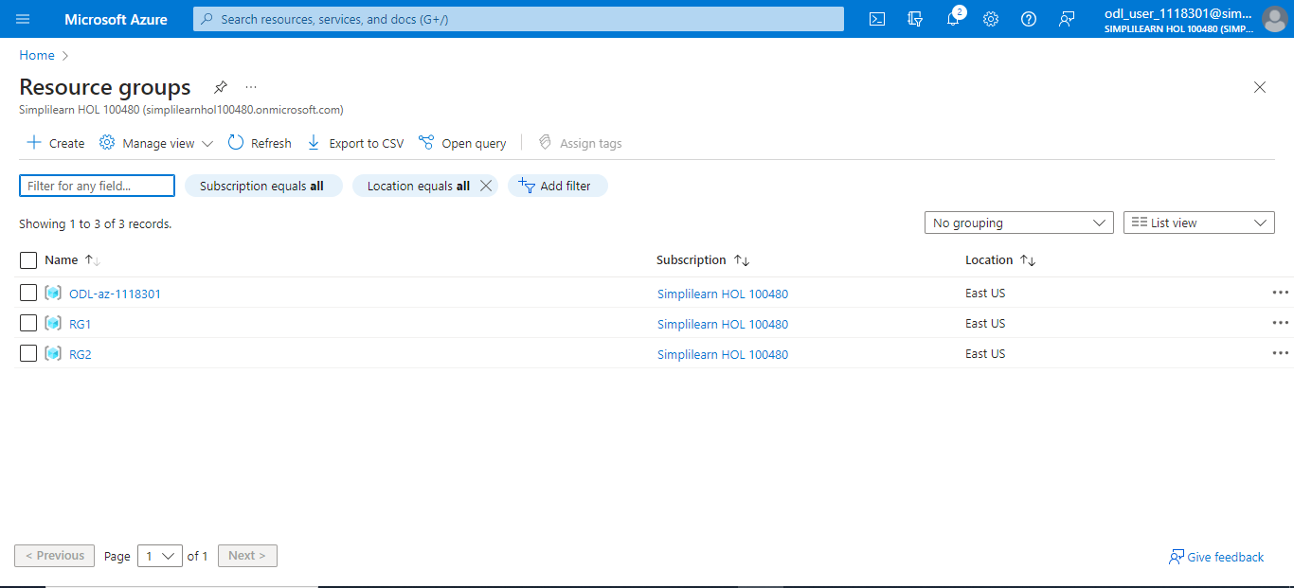

  - Select the storage account that is already created

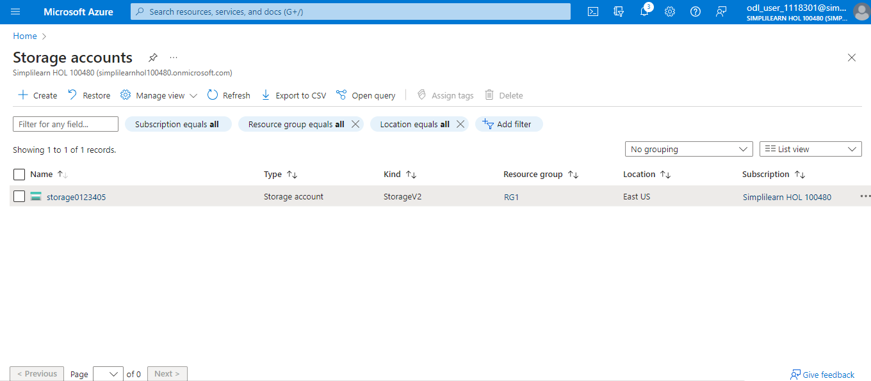

  - Navigate to the first resource (storage account) and select the Move option from the Overview blade of the respective resource. Here, the resource is moved from RG1 to RG2. Now, click on Move to another resource group.

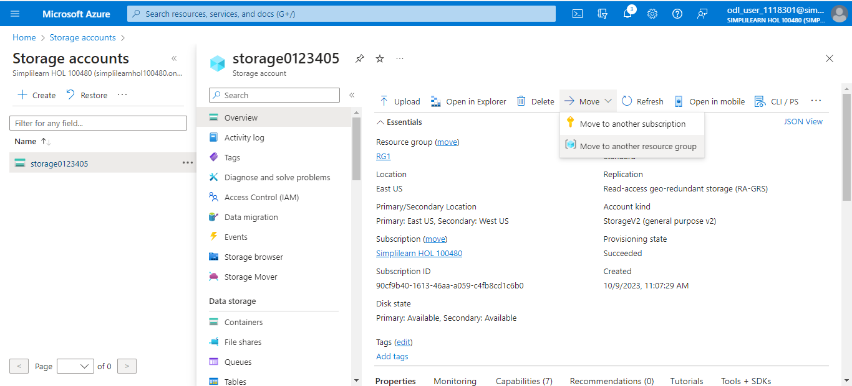

  - In the Move resources page, under the Source + target tab, select the target resource group name from the drop-down and click on Next

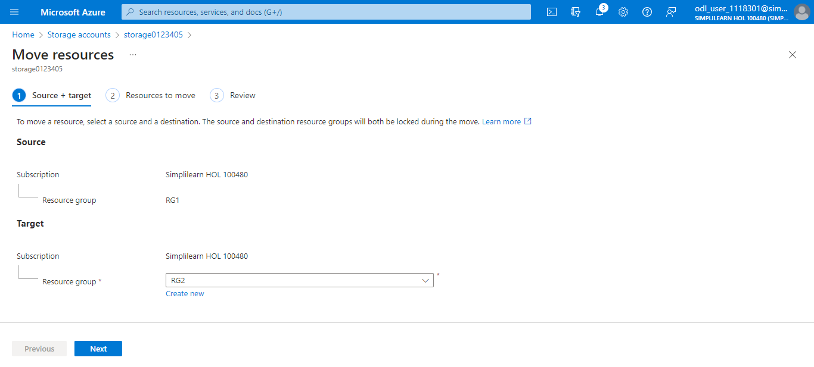

  - At this step, it will validate the resource before moving the resource to the target resource group.

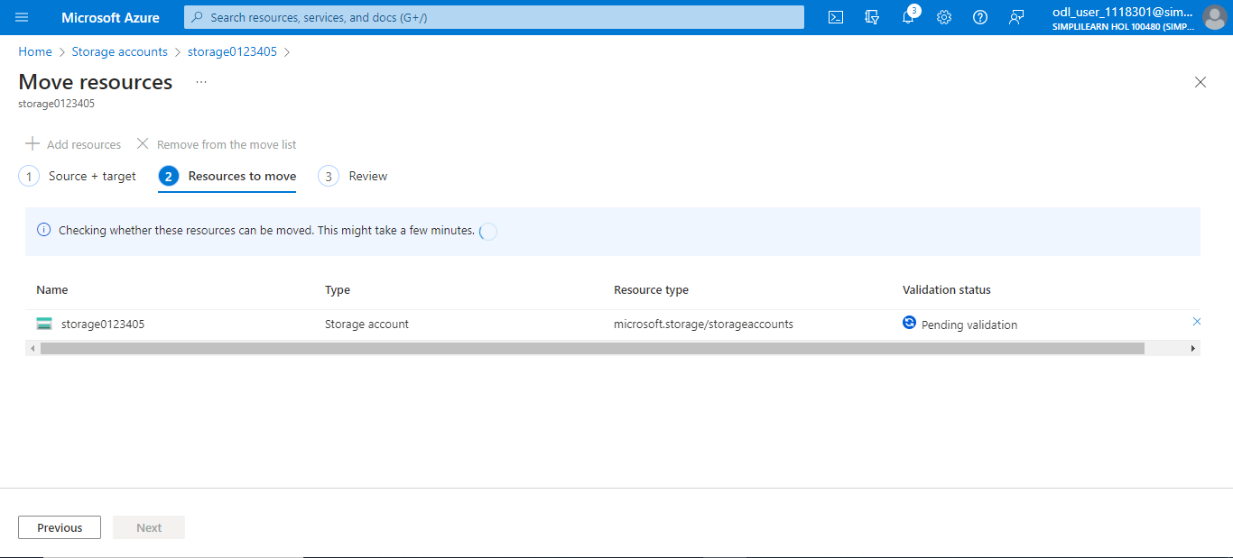

  - Once the validation is successful, you will see the message Succeeded. Click Next.

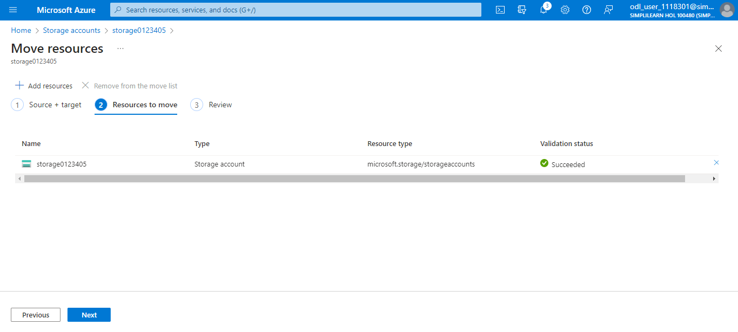

  - At last, check the box above the Previous button and click on Move to move the resource from RG1 to RG2

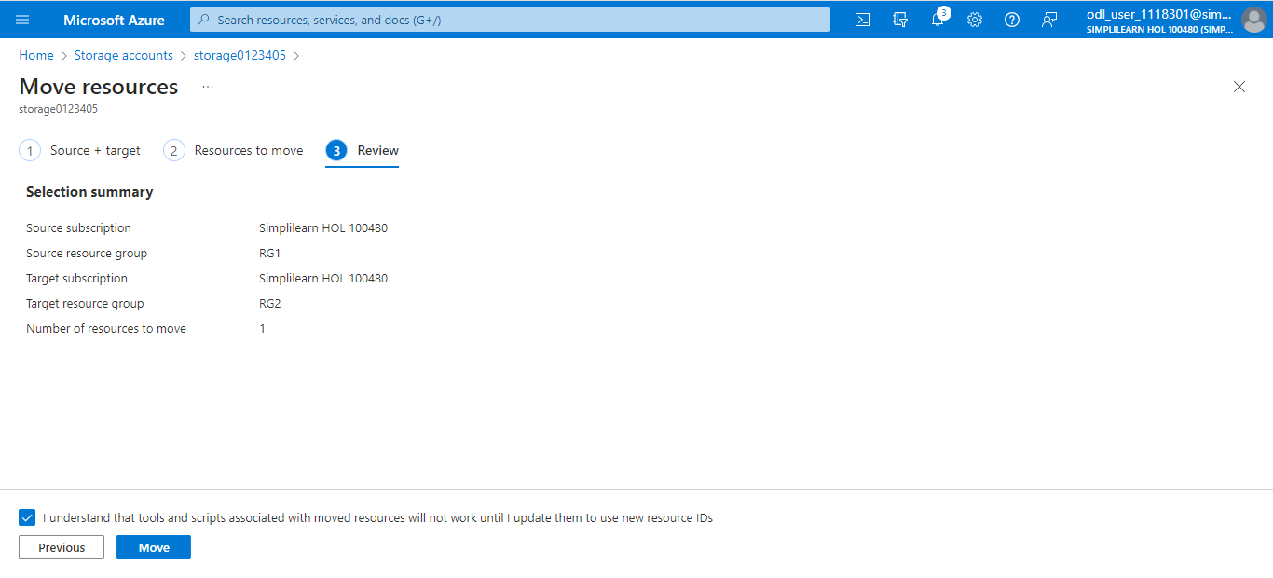

  - Once the resource starts moving, it will show in the Notifications bar. The resource is moved.

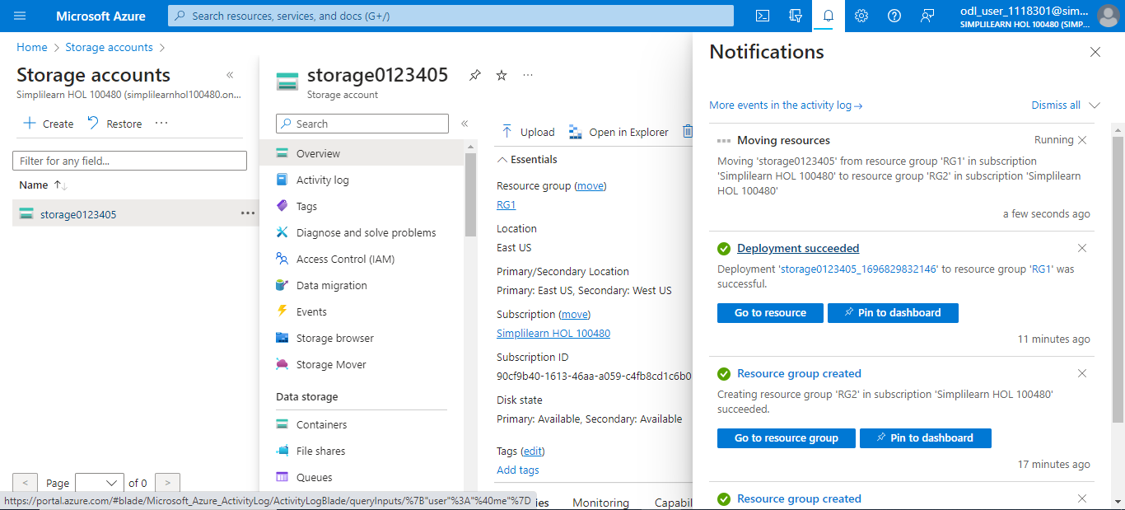

In this demo, you have successfully learned how to move a resource to another resource
group.

